**FAMILY EXPENSES**

**Team Id:** NM2025TMID20260

# Team Members: 4

## Team Leader: PRAKASAM.M

**Member 1:** RAHUL ROBINSON.J

**Member 2:** SANTHOSH KUMAR.E

**Member 3:** SHAILESH.S

**Problem Statement**: The project aims to develop a comprehensive expense calculation system using ServiceNow. This system will enable users to track and manage family expenses efficiently. It will include features such as expense categorization, budget setting, real-time tracking, and reporting capabilities. Utilizing ServiceNow's robust platform, the project will ensure seamless integration, user-friendly interface, and scalability to accommodate varying family sizes and financial complexities. The end goal is to empower users with the tools they need to make informed financial decisions and promote financial well-being within the family unit.

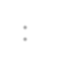

**Objective:** The "family expensive project" phrase seems to be a misunderstanding, but if referring to

ServiceNow's Strategic Portfolio Management (SPM), also known as Project Portfolio Management (PPM), its objective is to strategically manage and optimize a portfolio of projects by aligning them with business goals, providing real-time visibility into performance, and improving agility and resource allocation to deliver maximum customer value.

**Skills**: Service now Family expenses IOT Open Hardware platforms, Data Structures

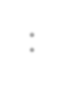

**TASK INITIATION**

**Milestone 1: update set**

## Activity 1: Local update set

1. Open service now
2. Click on All >> search for Local update
3. Click on new
4. Name: Family Expenses
5. Then click on submit and make current.

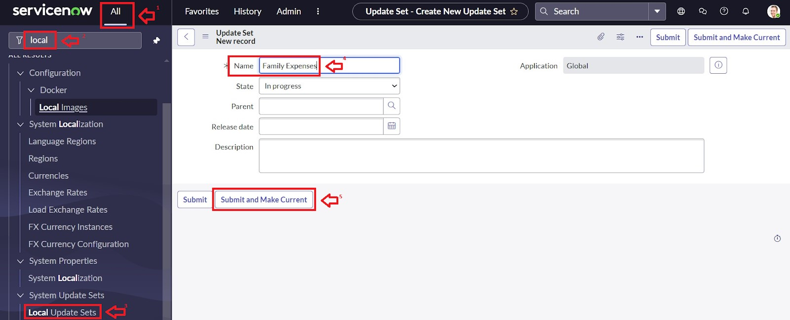

## Milestone 2: CREATION OF TABLE Activity 1: TABLE

1. Open service now.
2. Click on All >> search for Table
3. Click on new.
4. Label: Family Expenses, Name: Auto-Populated, New menu name: Family Expenditure.

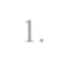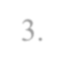

5.Go to the Header and right click there>> click on Save.

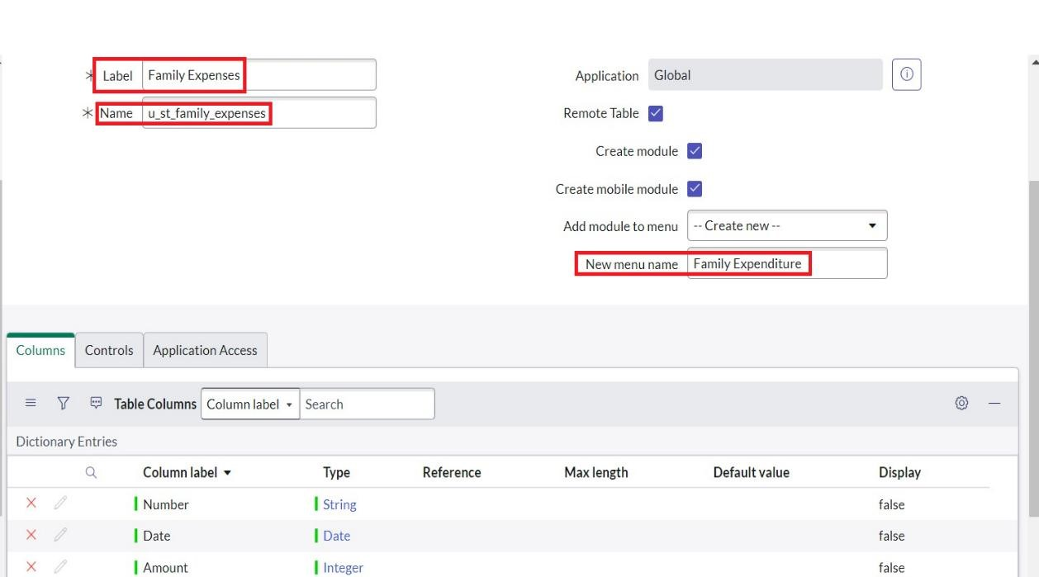

Activity 2: Creation of Columns (Fields)

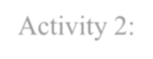

1.Near Columns Double click near insert a new row.

2.Give the details as: Column label: Number



Type: String

3.Double click on insert a new row again

4. Give the details as: Column label: Date

Type: Date

5.Double click on insert a new row again

6.Give the details as: Column label: Amount

Type: Integer

7.Double click on insert a new row again

8.Give the details as:

Column label: Expense Details

Type: String

Max length: 800



**ACTIVITY**



3

:



Making Number Field an Auto

-

Number



1

.Double click on the Number Field/Column.



2

.Go down and

double click on Advanced view



.In Default Value

3

:



Use dynamic default: check the box



Dynamic default value: Get Next Padded Number



4

.Click on Update.



5



Go

to All>> In the filter search for Number Maintenance >> select Number Maintenance



6

.Click on New.



7

.Enter the below Details

:



Table: Family Expenses



Prefix: MFE



8



Click on Submit.

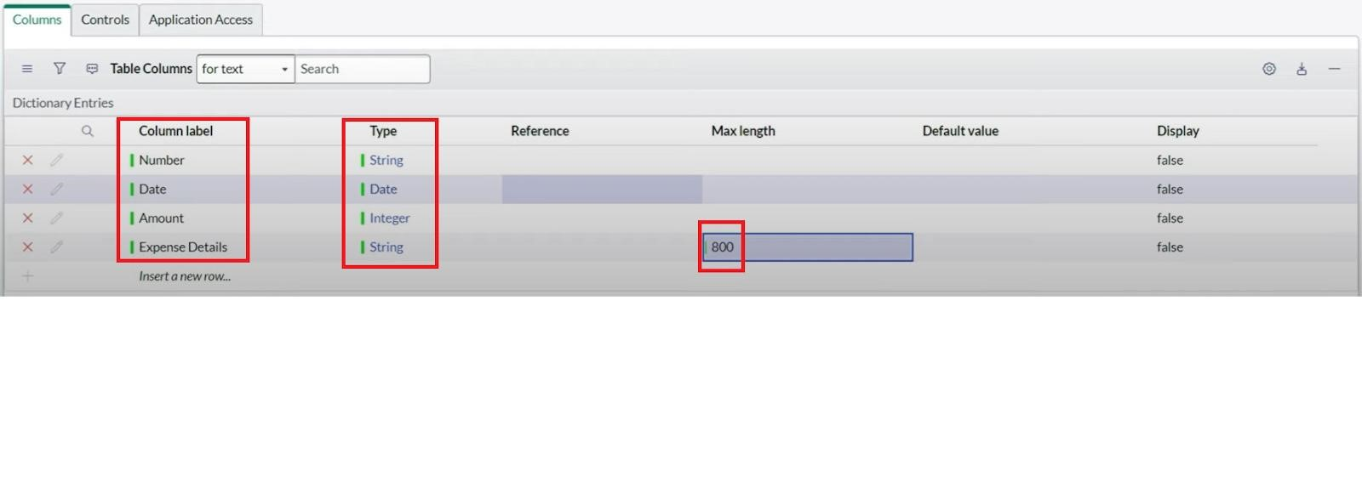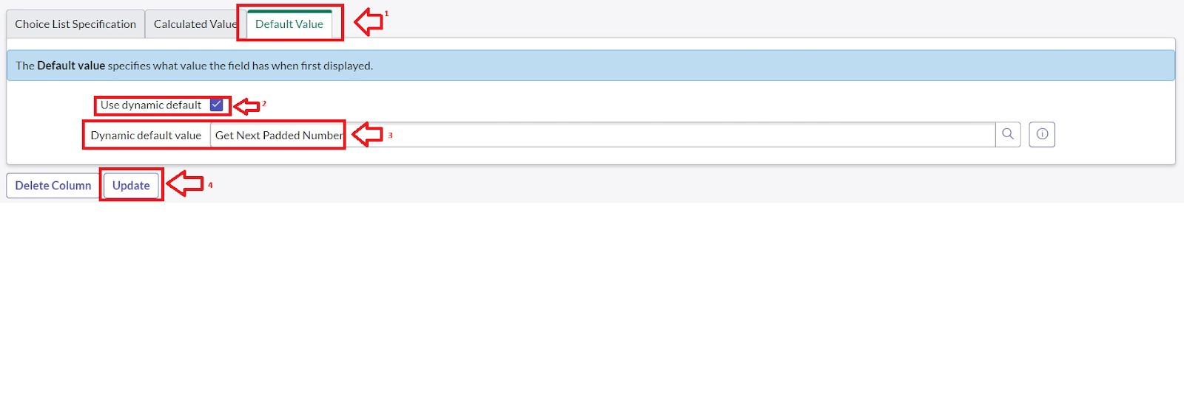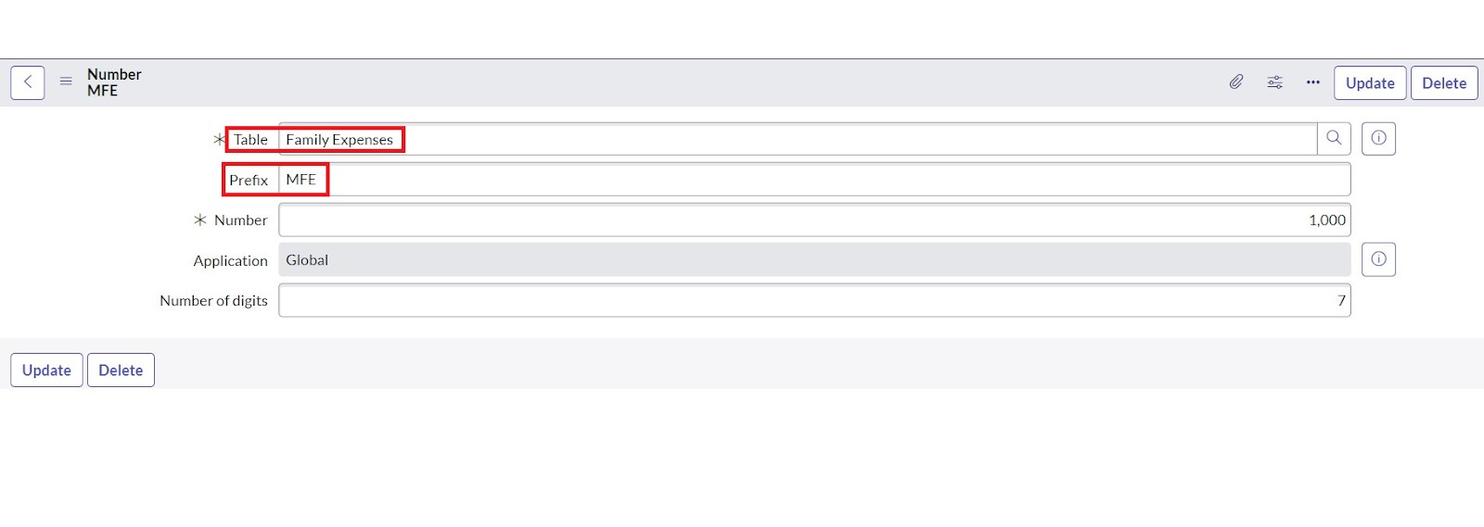

**ACTIVITY** 4: CONFIGER THE FORM

1. Go to All >> In the filter search for Family Expenses >> Open Family Expenses
2. Click on New
3. Go to the Header and right click there>> click on Configure >> Select Form Design



1. Customize or Drag Drop the form as per your requirement.

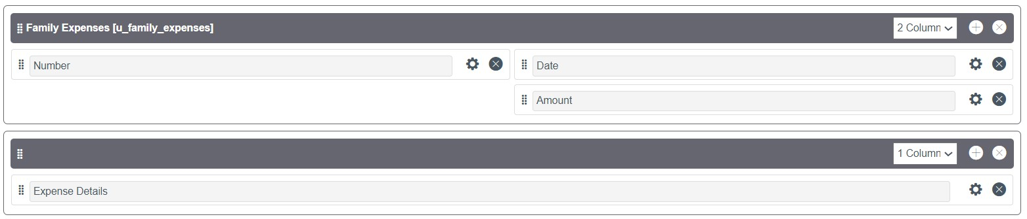

1. Make Number Read-Only Field by clicking on the gear icon and checking Read-Only 6. Make Date, Amount Mandatory Field by clicking on the gear icon and checking Mandatory



7. Click on Save.

## Milestone 3: CREATION OF TABLE(DAILY EXPENSES)

**Activity 1: Creation of Daily Exepenses Table.**

1. Go to All > In the filter search for Tables > click on New.



1. Enter the Details:

Label: Family Expenses

Name: Auto-Populated

New menu name: Family Expenditure

1. Go to the Header and right click there>> click on Save.

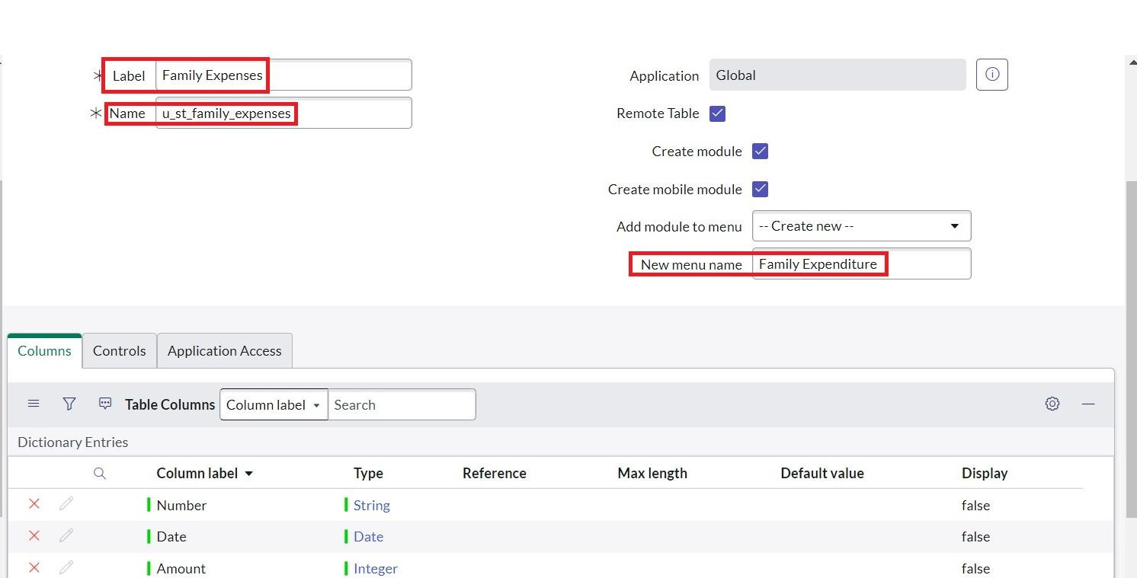

## Activity 2: Creation of columns(Field)

1. Near Columns Double click near insert a new row.



1. Give the details as:

Column label: Number

Type: String

1. Double click on insert a new row again
2. Give the details as:

Column label: Date

Type: Date

1. Double click on insert a new row again
2. Give the details as:

Column label: Expense

Type: Integer

1. Double click on insert a new row again
2. Give the details as:

Column label: Family Member Name

Type: Reference

Max length: 800

1. Double click on insert a new row again
2. Give the details as:

Column label: Comments

Type: String

Max length: 800

1. Go to the Header and right click there>> click on Save.



.



Activity 3**: Making Number Field an Auto-Number**

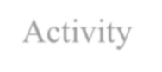

1. Double click on the Number Field/Column.
2. Go down and double click on Advanced view
3. In Default Value:

Use dynamic default: check the box

Dynamic default value: Get Next Padded Number



4.Click on Update.



.Go to All >> In the filter search for Number Maintenance >> select Number Maintenance

5



.Click on New.

6



7

.Enter the below Details

:



Table: Family Expenses



Prefix: MFE



8

.Click on Submit.



ACTIVITY4: Configer the form.



1.



Go to All >> In the filter search for Daily Expenses >> Open Daily E

xpenses



2.



Click on New

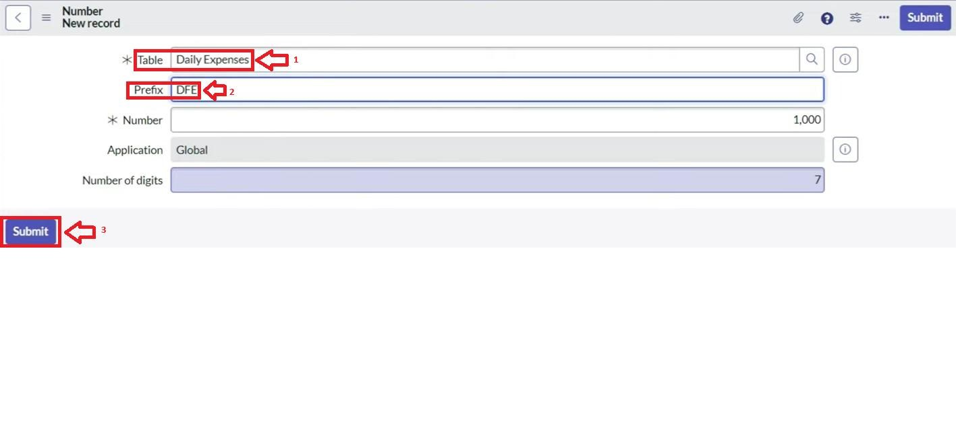

3.



Go to the Header and right click there>> click on Configure >> Select Form Design



4.



Customize or Drag Drop the form as per your requirement.



5.



Make Number Read

-

Only Field by clicking on the gear icon and checking Read

-

Only



6.



Make Date,

Family Member Name Mandatory Field by clicking on the gear icon and checking Mandatory



7.



Click on Save.

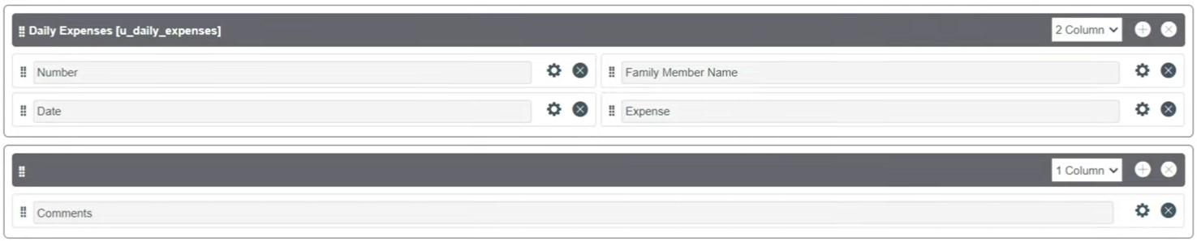

## Milestone 4: CREATION OF RELATIONSHIP

Activity 1: Creation of Relationship between Family Expenses and Daily Expenses tables

1. Go to All >> In the filter search for Relationships >> Open Relationships
2. Click on New.
3. Enter the details: Name: Daily Expenses

Applies to table: Select Family Expenses

Daily Expenses: Select Daily Expenses

4.Click Save.

1. Fill the following details to create a new ACL
2. Scroll down under requires role
3. Double click on insert a new row
4. Give task table and team member role
5. Click on submit
6. Similarly create 4 acl for the following fields

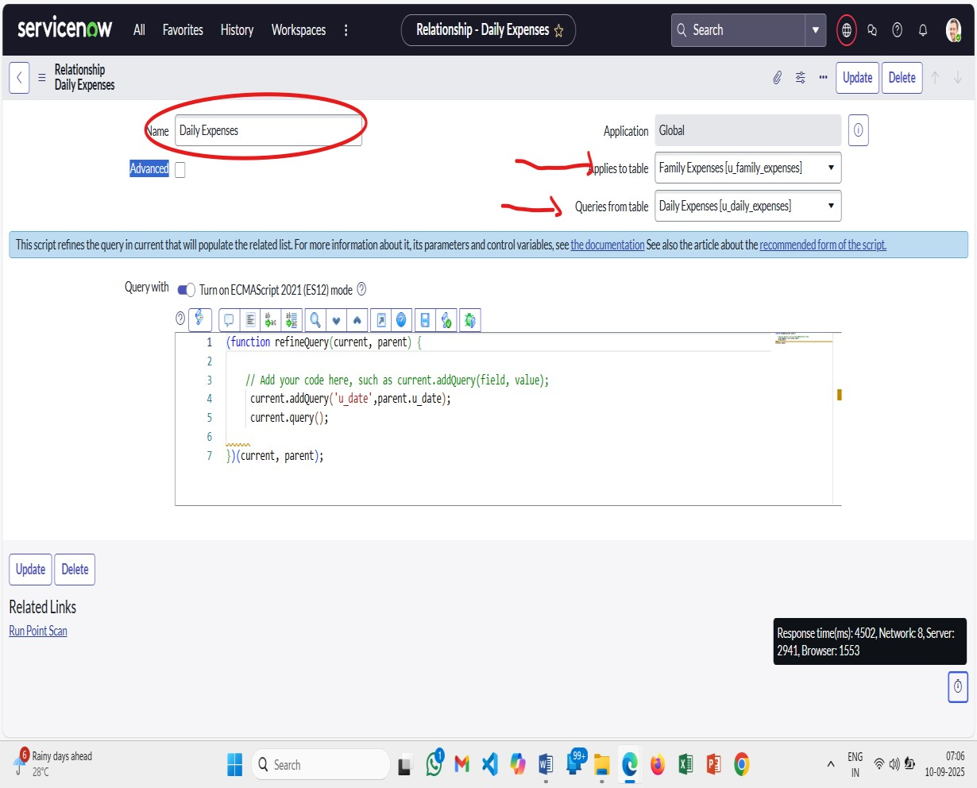

Milestone 5:Configuring Related List on Family Expenses

## Activity 1: Create a Flow to Assign operations ticket to group

1. Go to All >> In the filter search for Family Expenses >> Open Family Expenses

2.Click on New

3.Go to the Header and right click there>> click on Configure >> Select Related Lists

4.Add Daily Expenses to the Selected Area.

5.Click on Save

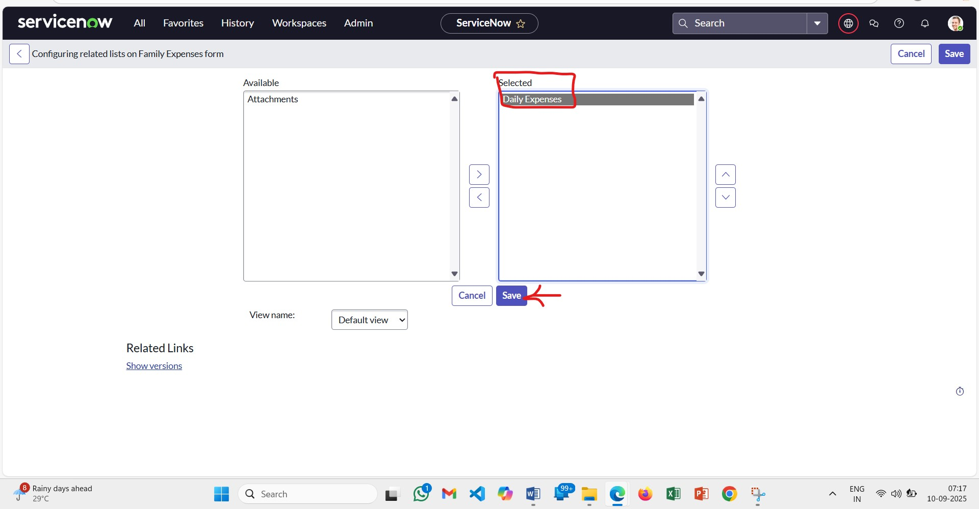

Milestone 6: Creation of Business Rules

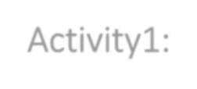

Activity1: Creation of Business Rules

1. Go to All >> In the filter search for Business Rules.
2. Under System Definition Select Business Rules then click on New.
3. Enter the Details:

Name: Family Expenses BR

Table: Select Daily Expenses

Check Advanced

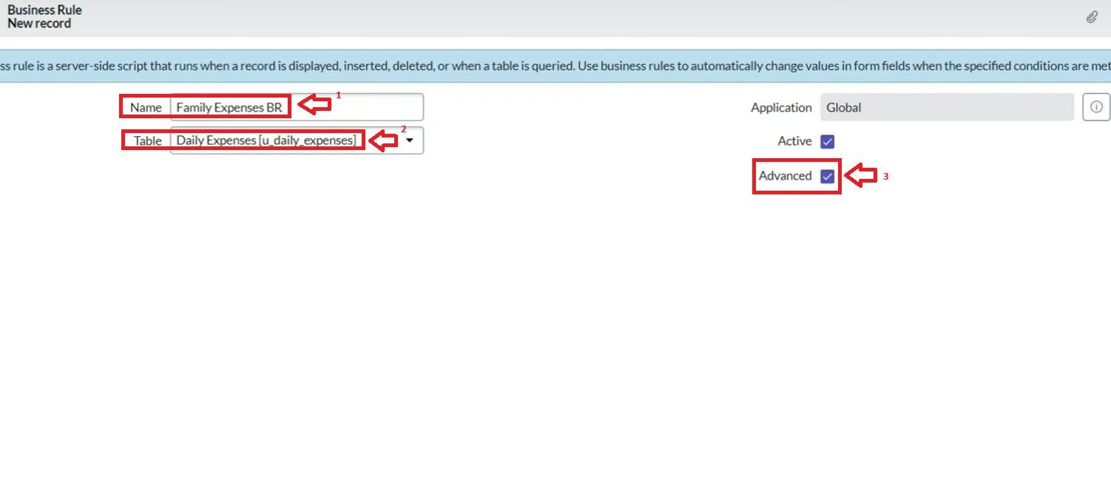

1. 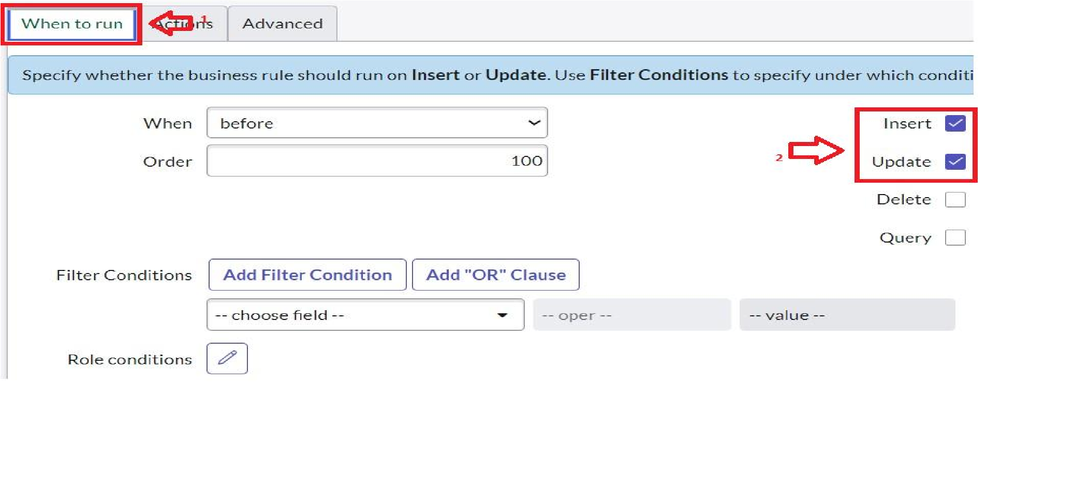In when to run Check Insert and Update
2. In Advance (we write the code): Write the below code >>

(function execute Rule (current, previous /*null when async*/) {

var Family Expenses = new Glide Record (' u_family_expenses ');

Family Expense. Add Query('u_ date',current.u _ date);

Family Expenses. query();

If (Family Expenses. next())

{

Family Expenses .u _amount += current .u_ expense;

Family Expenses .u_ expense_ details += ">"+current. u comments+":"+"Rs."+ current. u_ expense+"/-

";

Family Expenses. update();

}

else

{

var New Family Expenses = new Glide Record('u_ family_ expenses');

New Family Expenses. u_ date = current. u_ date;

New Family Expenses. u_ amount = current. u_ expense;

New Family Expenses .u_ expense_ details +=

">"+current.u_comments+":"+"Rs."+current.u_expense+"/-";

New Family Expenses. insert();

}

})(current, previous);

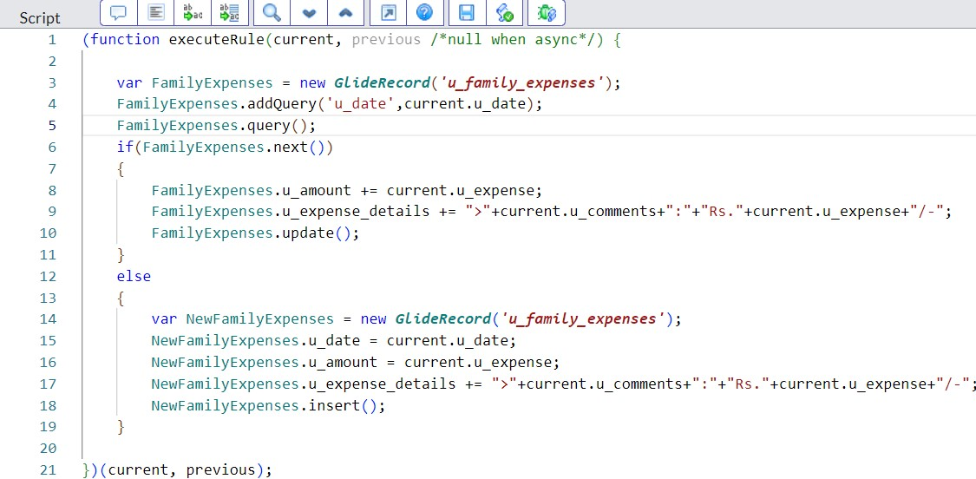

6. Go to the Header and right click there>> click on Save.

Milestone 7: Configure the Relationship

Activity1: Configure the Relationship

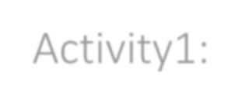

1. Go to All >> In the filter search for Relationships >> Open Relationships.
2. In that, open Daily Expenses Relationship.
3. For Applies to table: Select Family Expenses.
4. In Query with: write the below Query.

(function refine Query (current, parent) {

// Add your code here, such as current. add Query (field, value); current. add Query ('u_ date', parent. u_ date); current. Query ();

}) (current, parent);

1. Click on Update.

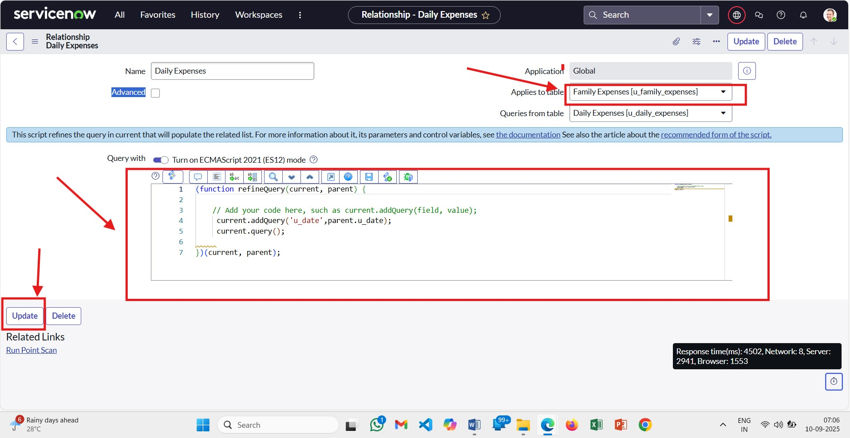

**Conclusion: A** successful ServiceNow "family" (project or platform) implementation, even a costly one, is concluded by demonstrating tangible business value through strategic alignment, improved operational efficiency, and positive user satisfaction. Achieving these outcomes requires senior expertise, comprehensive process mapping, a strong focus on configuration over customization, and ongoing transparent communication to manage risks, ensuring the project delivers its intended benefits and a positive return on investment.